TASK 3:

Revise and Refine your System

**1.      Refined problem statement**

1) What is your product, on a high level?

Our product provides a service of making showtimes of movies being presented at local movie theatres readily available for potential consumers of entertainment.

2) Whom is it for?

This product is available for any consumer that is in want of an entertaining experience that is

within a relatively close environment of where they live and the necessary information, we

provide to make that possible. Especially for movie fans who wants to watch the coming movie in ideal place for him or her.

3) What problem does it solve?

It provides readily available information for anyone who does not intuitively know or have

access to information regarding the closest proximity movie theatre or showing times for movies

in his or her area.

4) What alternatives are available?

Applications such as “Fandango” and “cinema” provide a relative competitive result to what we provide. Also, the more tedious methods are readily available such as finding theatres and showtimes manually through search engines.

5) Why is this project compelling and worth developing?

This project allows for some initial experience with being an individual within a development

team and understand the quirks and intricacies required to work as a cohesive unit to achieve

some common goal. Along with the previous statement, this provides an opportunity to test our

current technical skills gained as students and find areas that we need to improve and hone these

skills further.

6) Describe top-level objectives, differentiators, target customers, and scope of your

product.

Top-level objectives: Provide easily accessible and free upcoming movie information including movie show time and locations to potential movie consumers.

Differentiators: Our product is limited to the relative Atlanta area so the amount of traffic would

be less of an issue opposed to our competitors. And it costs less resources.

Target customers: Customers within the Metropolitan and greater Atlanta areas who interested in movies.

Scope of your product: The scope is relatively consistent with in the realm of movie

Entertainment.

7) What are the competitors and what is novel in your approach?

Our competitors include “Fandango” and “cinema”, and other movie information websites. We provide useful information exclusively for the Atlanta area.

8) Make it clear that the system can be built, making good use of the available resources and

technology.

There are many frameworks to build this system. For our project, we will Spring Boot as our framework, and use HTML, JavaScript and CSS to create our front-end, Java for back-end, then PostgreSQL for database.

9) What is interesting about this project from a technical point of view?

This project allows for our team to experience the use of full stack development in a single

process by needing to create and environment to display information from databases that we

create and then port said information over to a visual format to be used by potential consumers.

**2. Refined requirements**

1) Retrieve Movie Times

Introduction: This requirement is related to the need of displaying pertinent data for the films on the system.

Inputs: A name or date regarding a specific film you are trying to watch at a local theatre.

Requirements Description: A robust amount of data for films that are being shown at local theatres to be entered into a database system.

Outputs: The system will then display all results that are possibly related to the input and thus showing a schedule of films being run at a theatre.

2) Retrieve Specific Movie

Introduction: This requirement is related to the need of finding specific information in regards to a specified film.

Inputs: A name or date regarding a specific film you are trying to watch at a local theatre.

Requirements Description: Data from a multitude of different films being shown and input into a database to be displayed.

Outputs: The system will return a list of films that are related to the input and then give a certain amount of information on the searched film.

3) Ticket Retrieval

Introduction: This requirement is related to the need of providing an electronic version of a ticket to gain access toward attending a film at a theatre.

Inputs: A credit or debit card of some kind is needed in order to perform an epurchase of a ticket for a film at a local theatre.

Requirements Description: A secure encrypted system that allows a customer to make and charge a payment online.

Outputs: An e-ticket will be sent to a device of a customer that can be used to attend a film at a local theatre.

4) Stream Trailer

Introduction: This requirement is related to the need of providing a short clip displaying an introduction to films being shown at local theatres.

Inputs: A name of the film you are searching for.

Requirements Description: A robust amount of short video files that are uploaded to a database system in order to be displayed on the system.

Outputs: Shorts clips showing scenes from films that are being shown at local theatres.

5) Display Development Team Info

Introduction: This requirement is related to the need of providing information on the development team of the system.

Inputs: No input required. Simply click relevant menu option.

Requirements Description: Information that amounts to a synopsis on the relevant members with in the development team to be uploaded onto the database.

Outputs: Documents that display the abilities and skills of the development team members.

6) Show Theatre Locations

Introduction: This requirement is related to the need of providing locations and information of local theatres you would want to visit.

Inputs: A name of a film you believe to be currently shown at a local.

Requirements Description: Information in regard to films being shown currently, also operating hours and locations of local theatres that have said films available.

Outputs: Times relating to the input of the film being searched and local theatres that are currently showing the film.

**3. Refined Use Case Diagram**

In this part, we use buy tickets as our use case to show class diagram, which is shown below.

Use case: Buy Tickets

Actors: Customers, Database, Payment Service

Description: The website contains the ability to purchase tickets electronically for showings at local theatres. As customer goes to the website, he or she would use UI to browse the recommendations for movies, then select movie time and pay for tickets.

Alternate Paths: You could visit your local theatre and pay for tickets upon arrival.

Pre-Condition: The local movies theatres provide information and available tickets to be sold to customers, that is facilitated through our platform.

Class diagram:

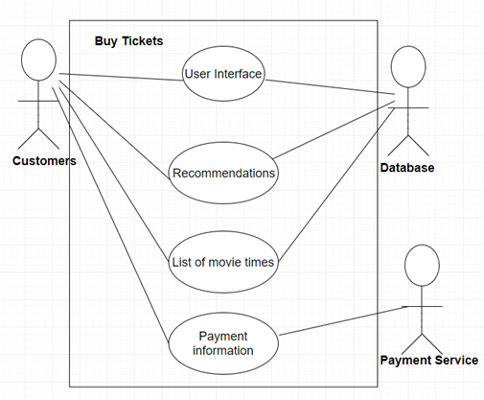

Figure: Class Diagram

4. Refined class diagram

**Class Diagram**

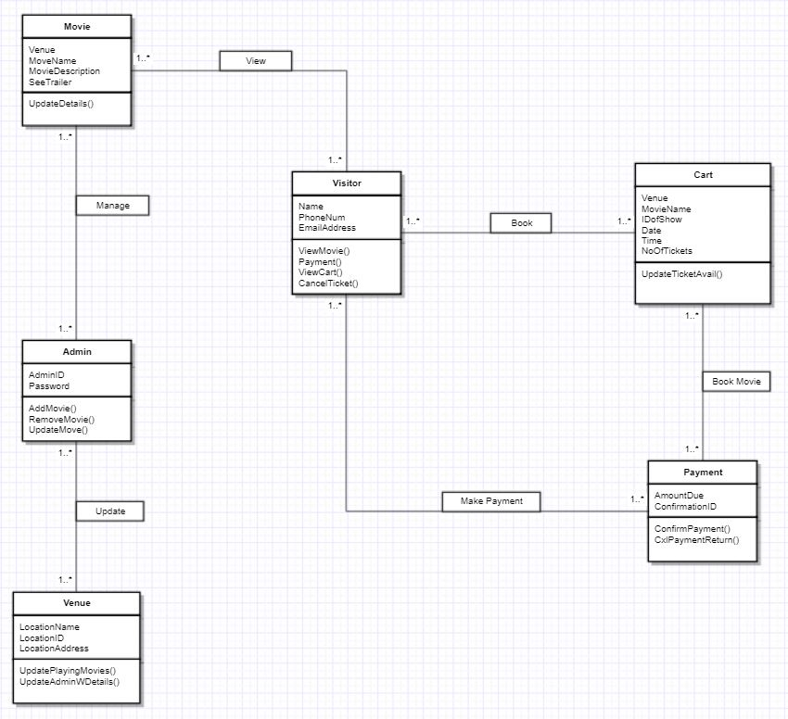

|  |  |  |  |  |
| --- | --- | --- | --- | --- |
| **Class Diagram Analysis** | | | | |
| Objects | Associations | Multiplicity (Instances) | Attribute | Defined Operations |
| Venue | Admin | Update Admin: One or more | Location Name  Location ID  LocationAddress | UpdatePlayingMovies()  UpdateAdminWDetails() |
| Admin | Venue  Movie | Update by Venue:One or more instances  Manage Movie: One or more | AdminID  Password | AddMovie()  RemoveMovie()  UpdateMovie() |
| Movie | Admin  Visitor | Manage by Admin: One or more  View by Visitor: One or more | MovieName  MovieShow  Venue  SeeTrailer | UpdateDetails() |
| Visitor | Movie  Cart  Payment | View Movie: One or more  Book via Cart: One or more  Make a Payment: One or more | FullName  PhoneNum  EmailAddress | ViewMovie()  Payment()  ViewCart()  CancelTicket() |
| Cart | Visitor  Payment | Book for Visitor: One or more  Book Payment: One or more | Venue  MovieName  IDofShow  Date  Time  NoOfTicketsAvailable | UpdateTicketAvail() |
| Payment | Visitor  Cart | Make Payment via Visitor: One or more  Book Movie via Cart: One or more | AmountDue  ConfirmationID | ConfirmPayment()  CxlPaymentReturn() |